**myPortfolio: Easy Way to Create Your Amazing Portfolio**

Output:

Home page

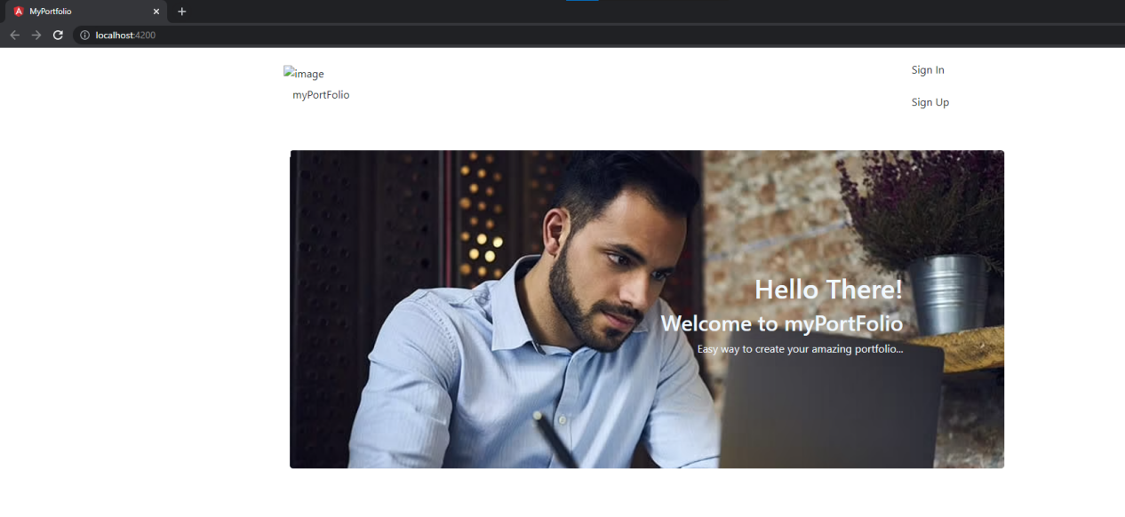

Sign-up page

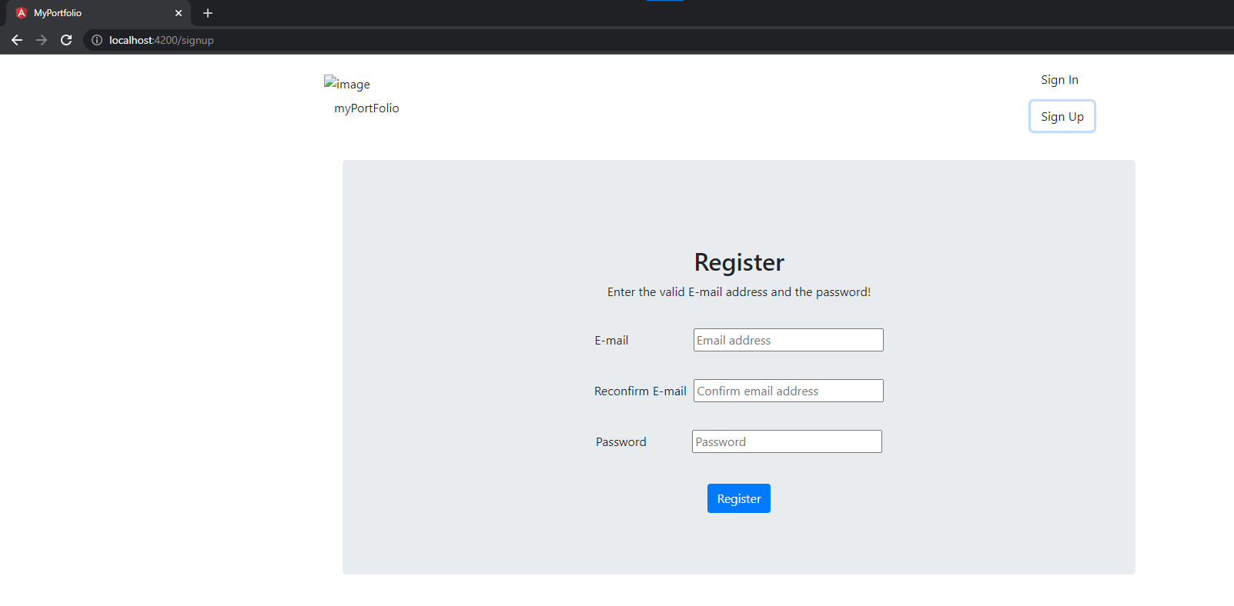

Login page

